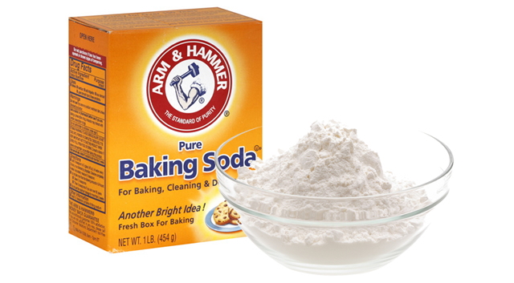
Make Baking Soda Toothpaste- 25 pts
Looking to get away from all the chemicals in store bought toothpaste? Luckily, there's no need to head out to the health food store—it's easy to make environmentally friendly,
chemical-free toothpaste at home using one of the most common, inexpensive pantry staples in the American kitchen: baking soda.

Say goodbye to sodium lauryl sulfate and hello to simple living!

What You Need:
1/4 cup baking soda
1 tablespoon salt
Water
Peppermint oil or some flavoring
Mixing bowl
Spoon
Toothbrush
Jar with lid
Measuring cups and spoons
Internet access (optional)

What You Do:
1. Mix the baking soda and salt together in the mixing bowl.
2. Add a few drops of peppermint oil to the mixture.
3. Gradually add small amounts of water to the dry ingredients, stirring constantly as you do.
4. Continue adding water until the mixture reaches a thick paste.
5. Wet your toothbrush and add a pinch of the mixture to the bristles.
6. Brush your teeth, rinse your mouth out with water, and analyze the results.
7. End the activity by looking up the ingredients in regular, store bought toothpaste. Can you identify all the ingredients? Compare it to the toothpaste you have just made and decide which you prefer.
8. Bring your sample into class to compare with other students.

© Copyright 2006-2012 Education.com All Rights Reserved.

