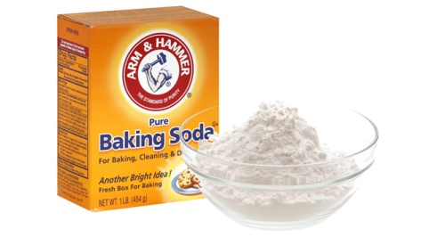
Make Baking Soda Toothpaste Questions:(25 pts)

- Which type of toothpaste do you prefer, homemade or store bought? Why?

- Look up ingredients in store bought toothpaste. Can you identify all of the ingredients? Which ones do you know? Which ones are ones that you don’t know? Pick three of the ingredients you don’t know and look up their function. List them below.

- Which type do you think does a better job of cleaning your teeth, homemade or store bought? Can you find any research to support your decision? Can you find research to disprove your decision?

- Compare the cost of store bought toothpaste to homemade. Here is some information you will need to make your comparisons. Crest is $3.97 for 6.2 ounces. Baking Soda is $.59 for 16 ounces. Each serving of flavoring is $.10 for a half cup batch of homemade toothpaste. Which is less expensive? Why do you say that?

- Extra Credit- Try and prepare a second batch of homemade, but use a different flavoring. Does that make it better or worse? Bring samples into class.

